Tatu Bogdan – CTI EN 3.1

RING OSCILATOR

* 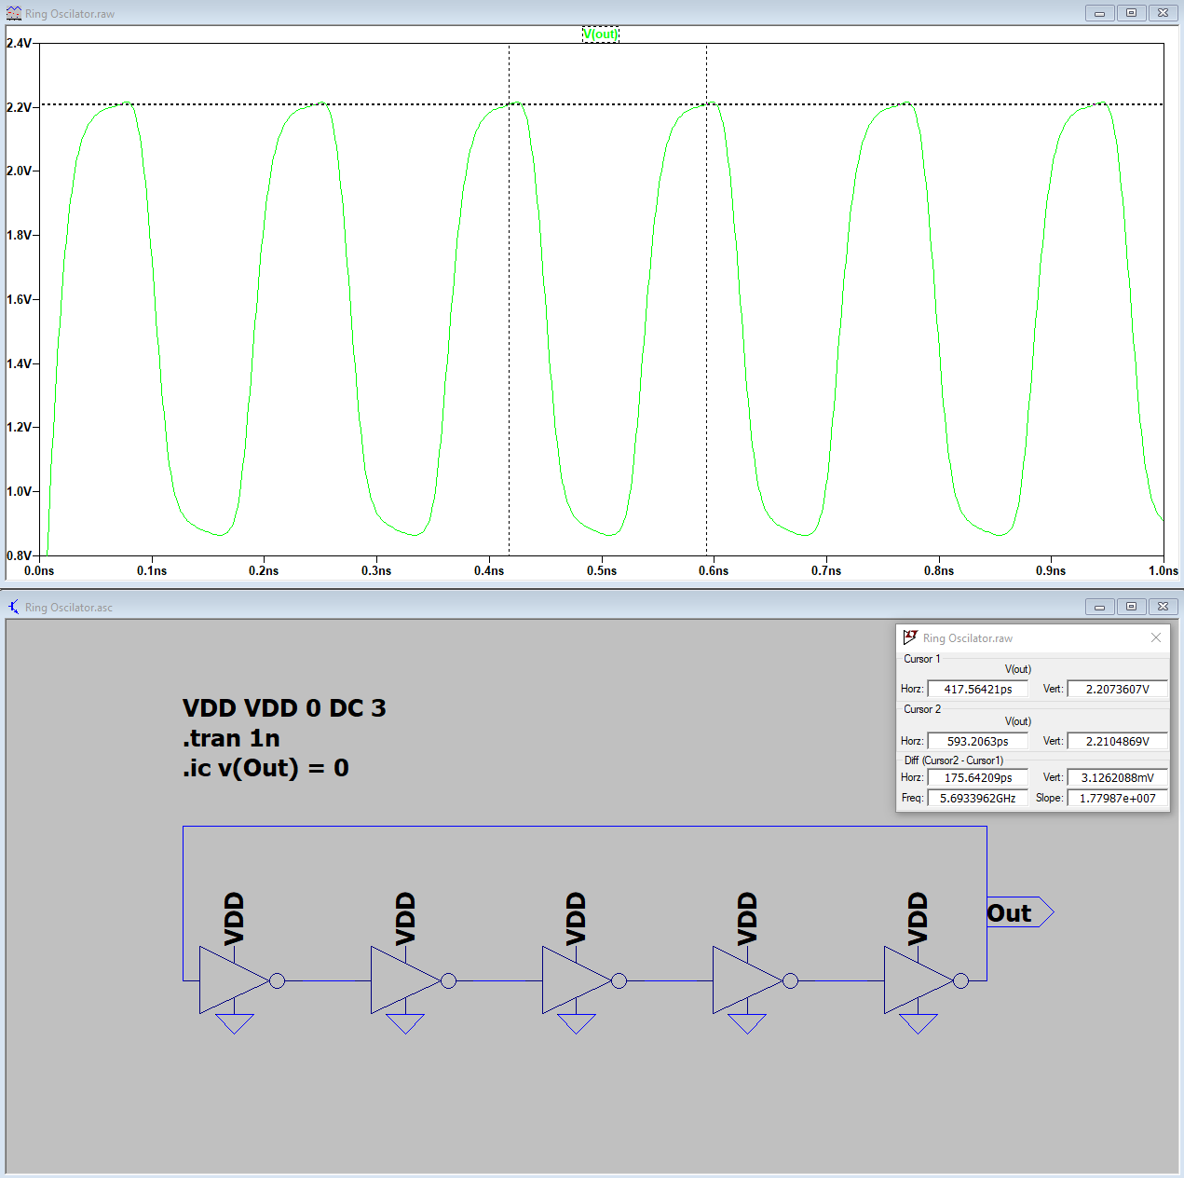Vdd = 3V Cp = 0

Frequency: 5.66 GHz

Period: 175 ps

* 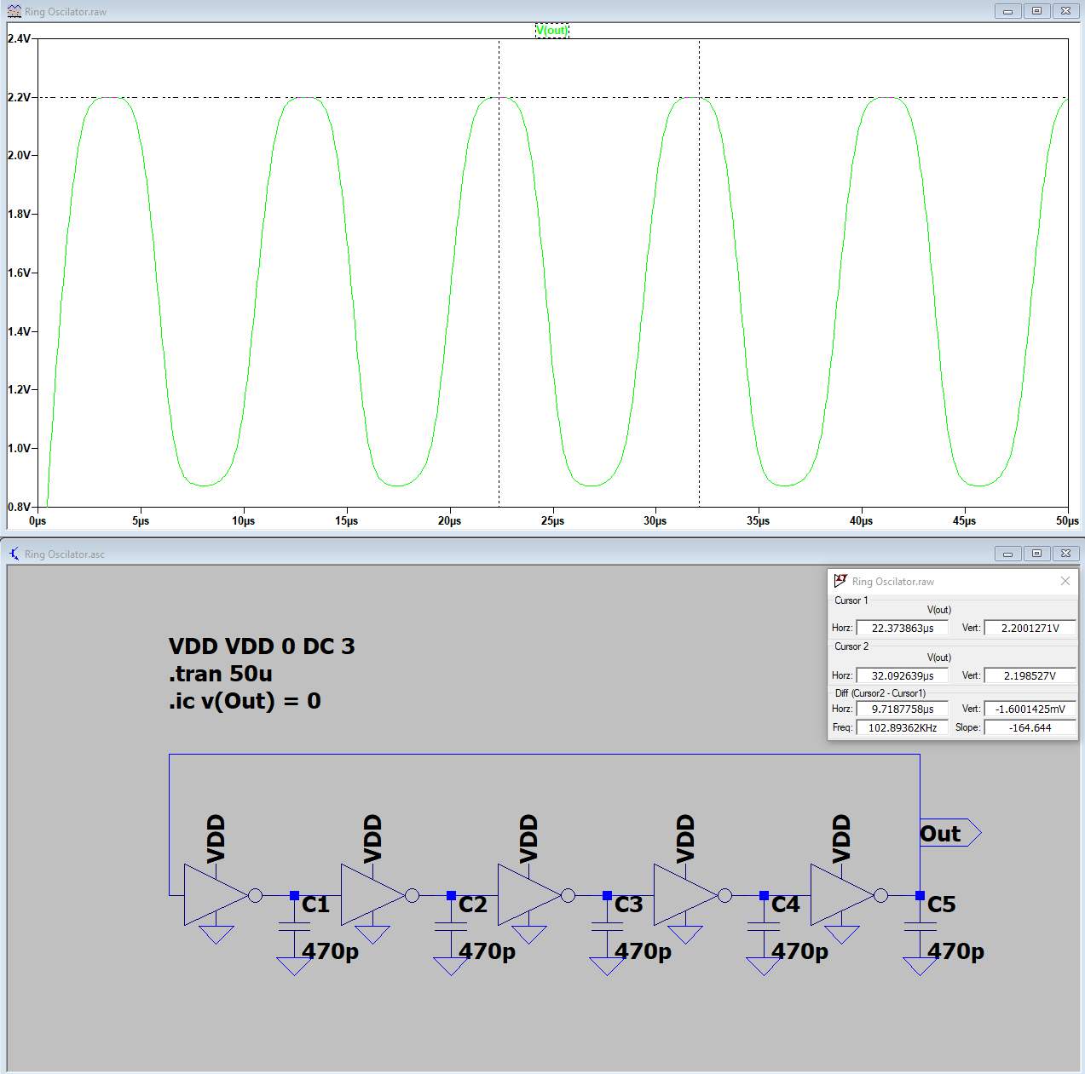Vdd = 3V Cp = 470pF

Frequency: 102 KHz

Period: 9.71 us

* 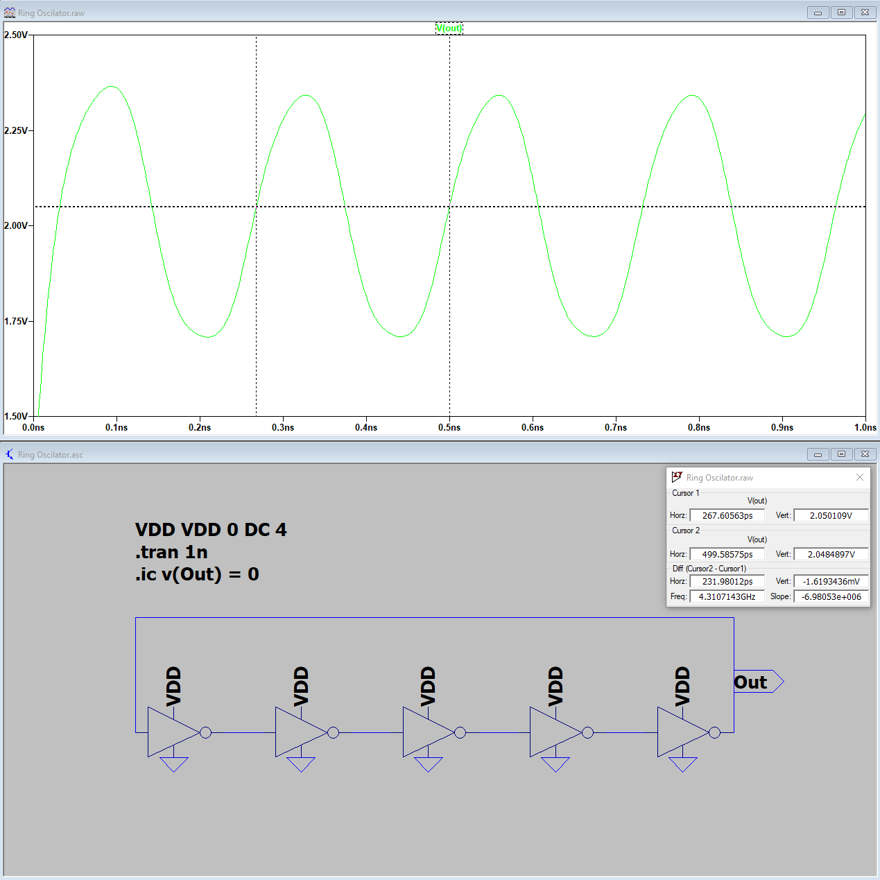Vdd = 4V Cp = 0

Frequency: 4.31 GHz

Period: 231 ps

* 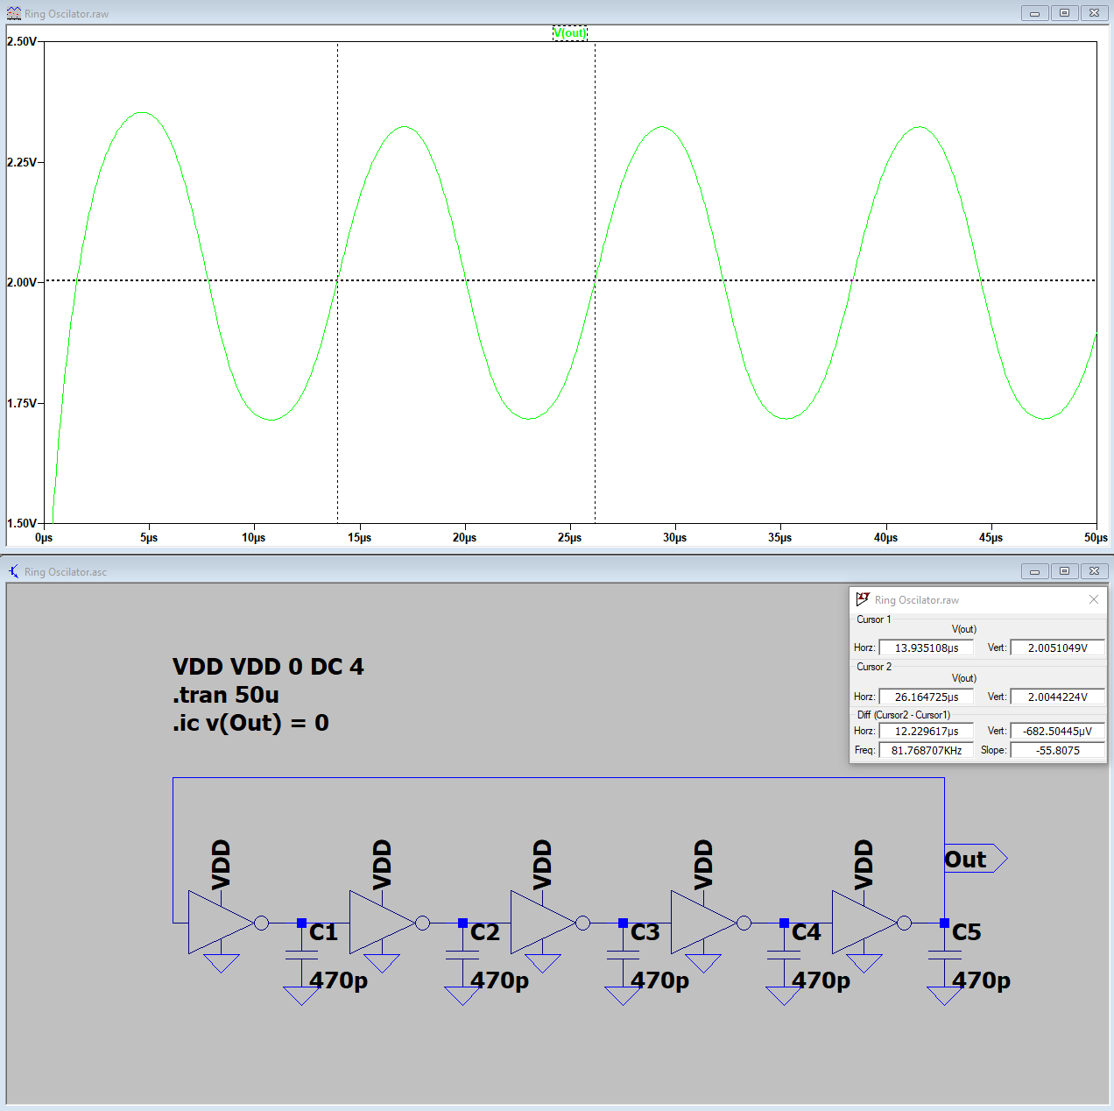Vdd = 4V Cp = 470pF

Frequency: 81.7 KHz

Period: 12.2 us

* 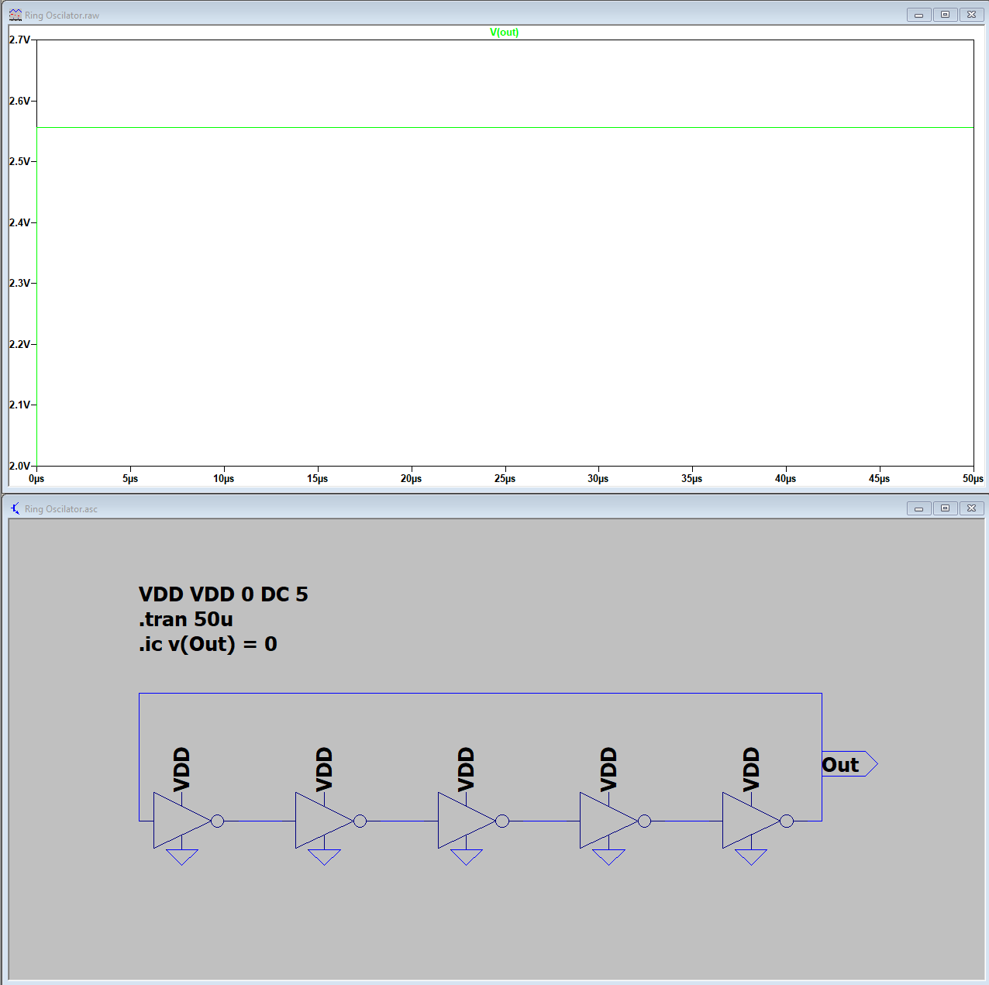Vdd = 5V Cp = 0

Frequency: N/A

Period: N/A

* 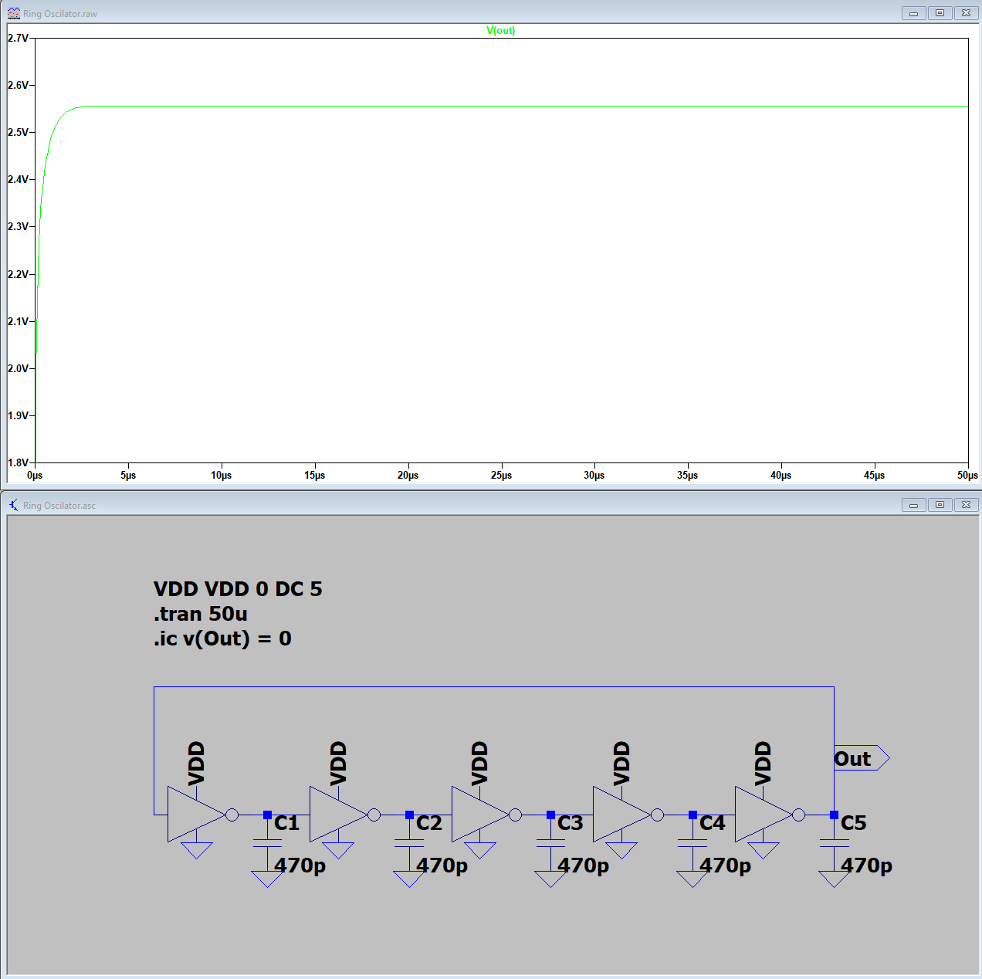Vdd = 5V Cp =470pF

Frequency: N/A

Period: N/A

* 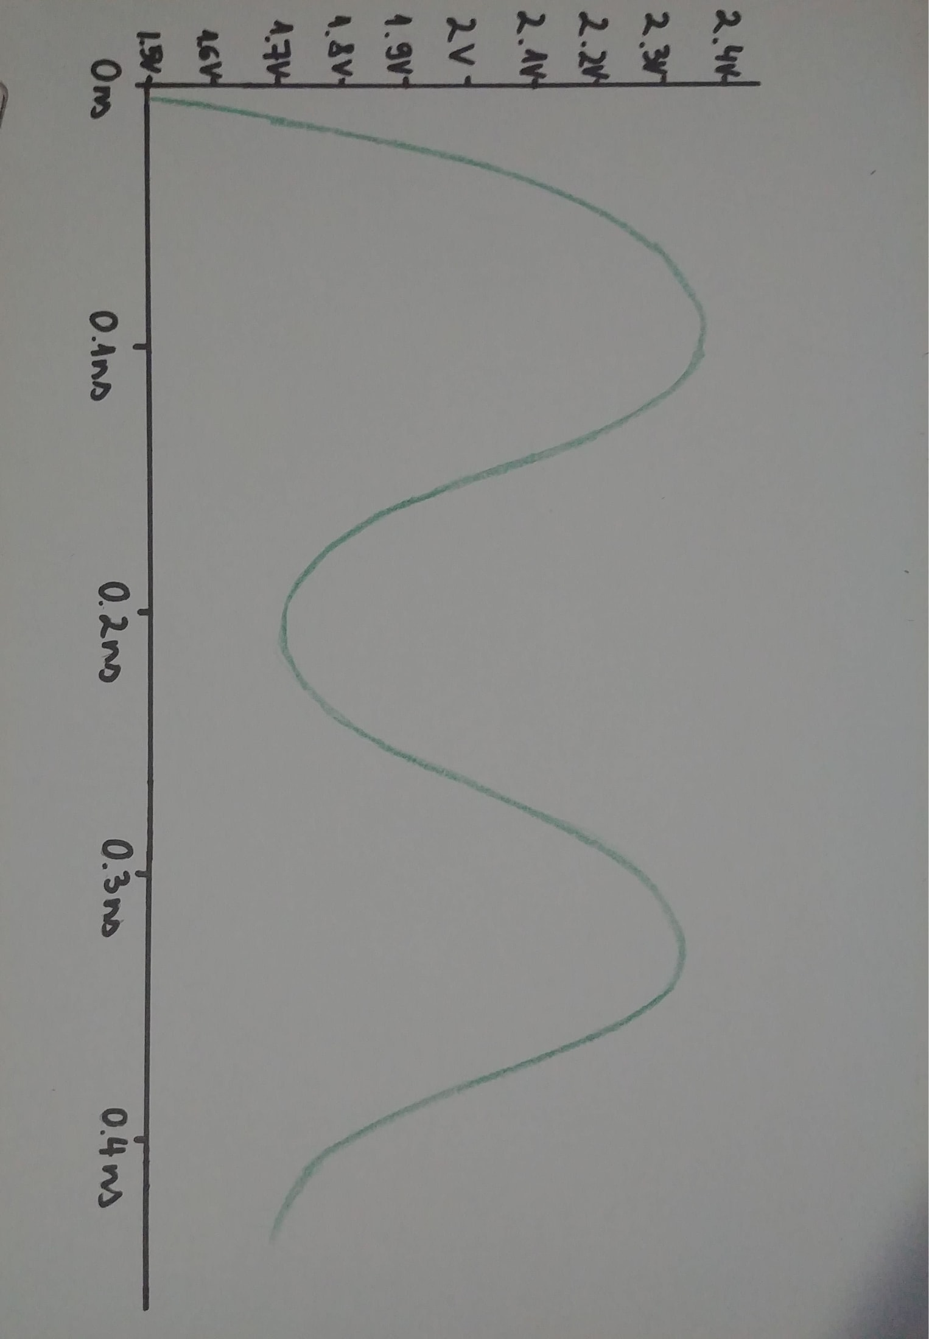Vdd = 3V Cp = 0

RC OSCILATOR

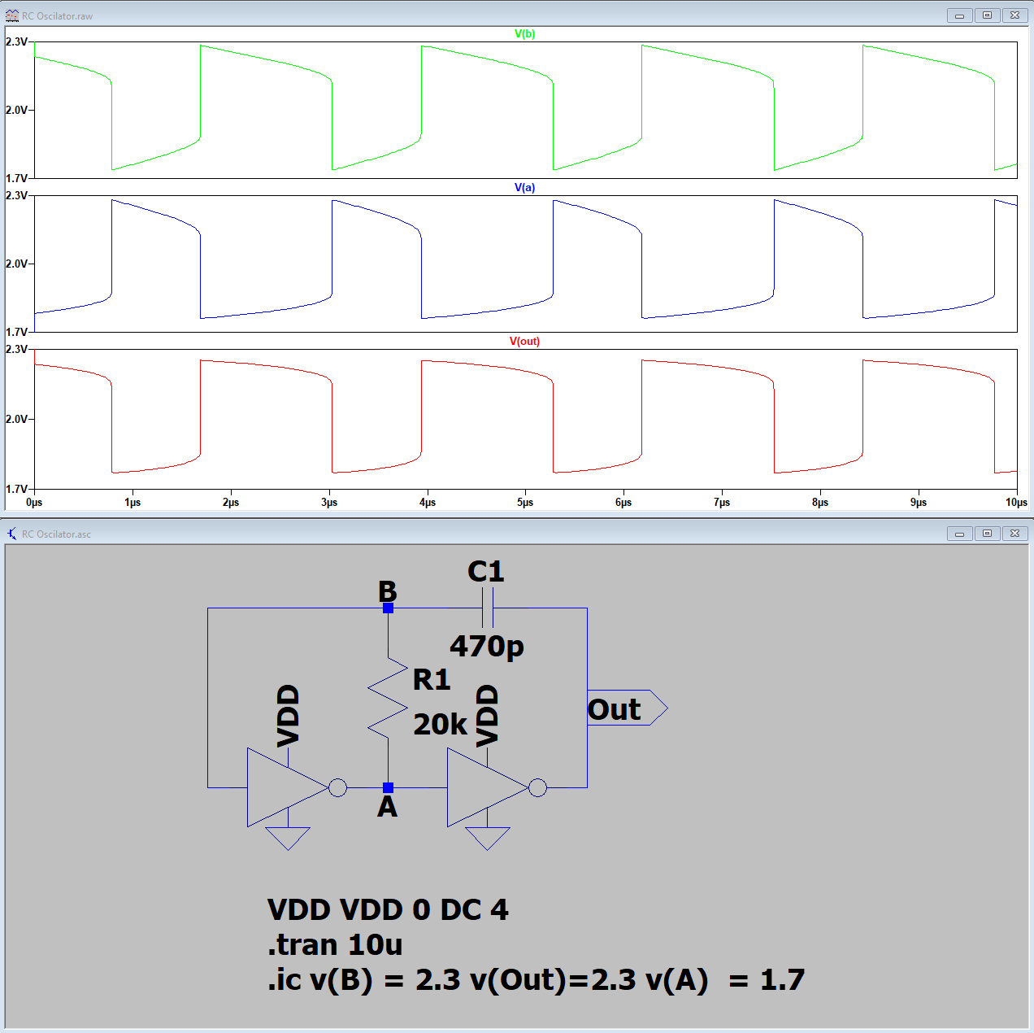Got the RC Oscilator working with R = 20kΩ